Lab 3 informatics screenshots. Akkushimov Viktor

A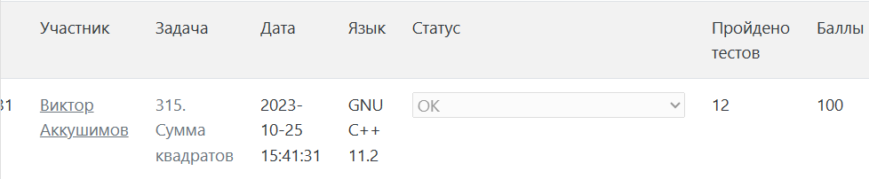

D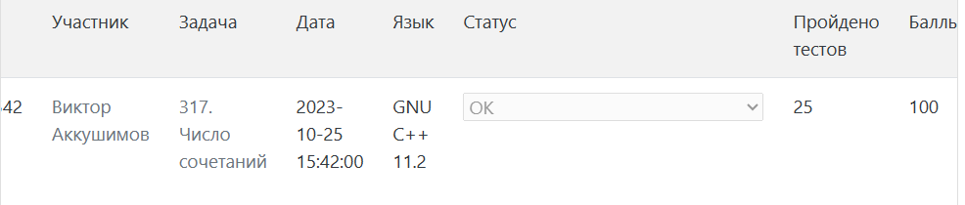

H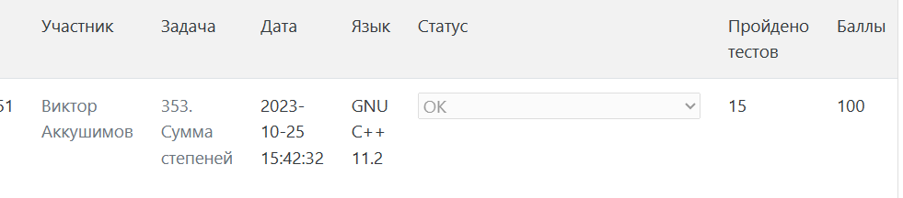

C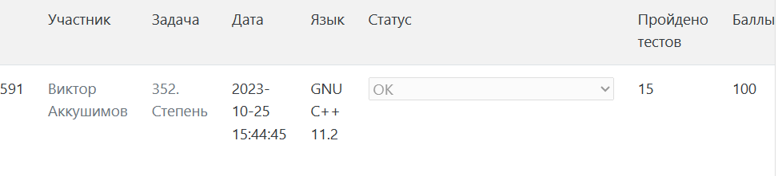

I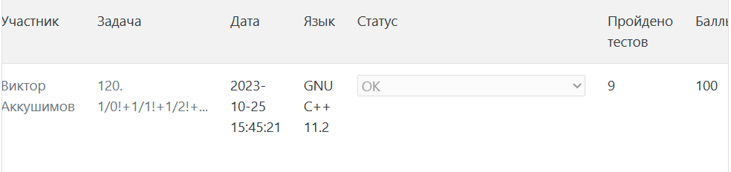

A